**Capstone project**

INDEX

* *TECHNOLOGIES*
* *PROJECT MANAGEMENT -JIRA STORIES*
* *DATABASE DESIGN AND SETUP*
* *BACKEND REST API DEVELOPMENT*
* *FRONEND DEVELOPMENT*
* *TESTING AND DEVOPS USING JENKINS.*
* *PROJECT SCREENS*

|  |  |
| --- | --- |
| **Technologies used** | |
| *Project Management* | *JIRA* |
| *Database Management* | *MySQL* |
| *Backend Development* | *Java Programming, JPA, Hibernate, Spring Boot* |
| *Frontend Development* | *Angular, Bootstrap, HTML/CSS, Javascript, and NodeJS* |
| *Testing and DevOps* | *Selenium, TestNG, Jenkins, GitHub, Docker,* |

**PROJECT MANAGEMENT JIRA STORIES**

Sprint User stories:

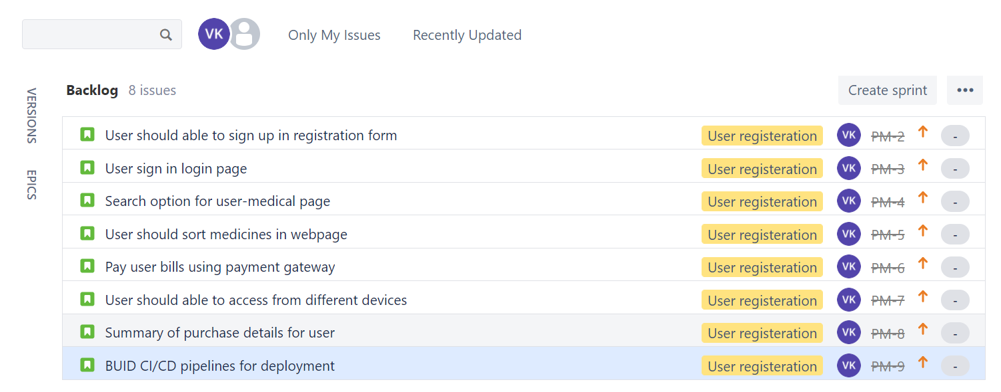

**DATABASE DESIGN AND SETUP**

User Creation

* User name: ecommerceapp
* Password: ecommerceapp

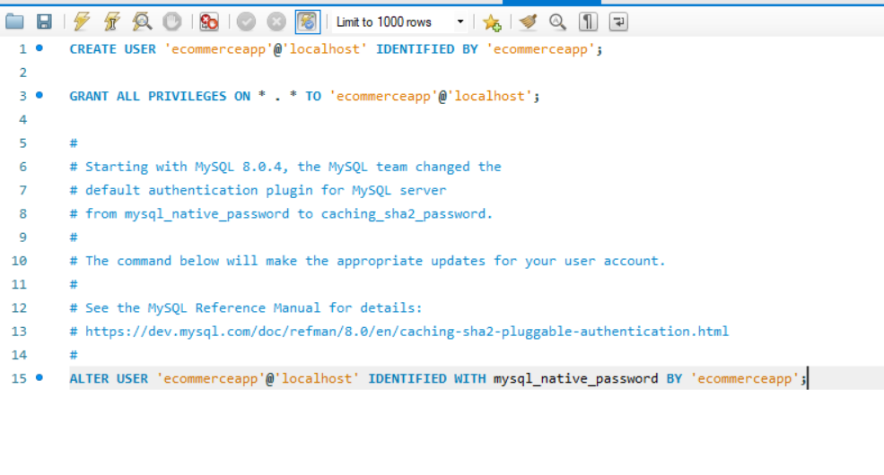

Create DB and Table:

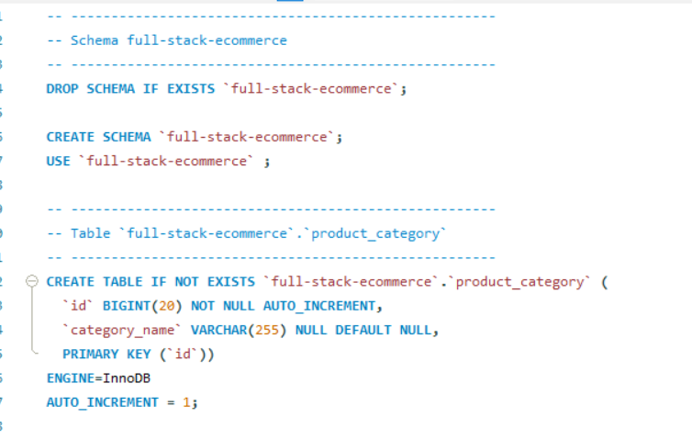

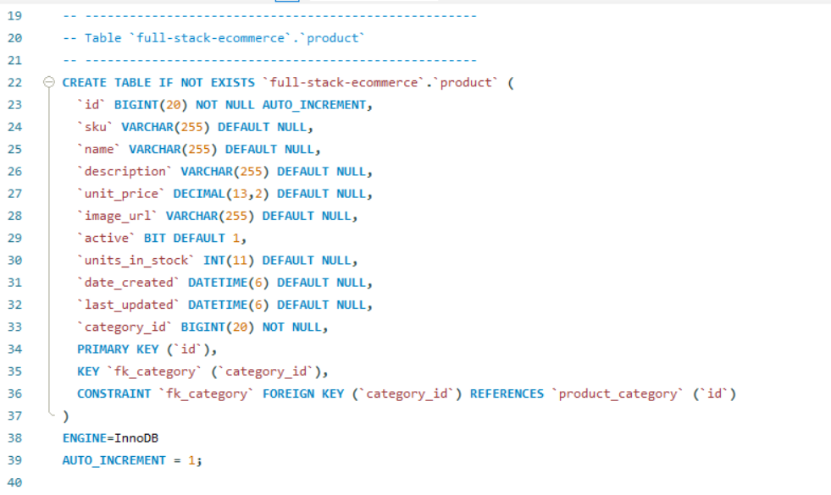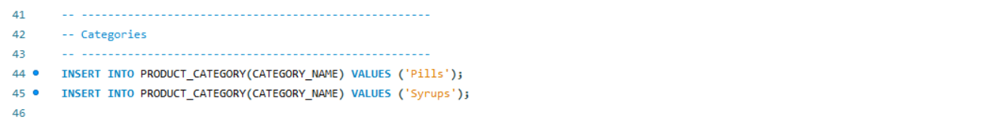

Inserting data into tables:

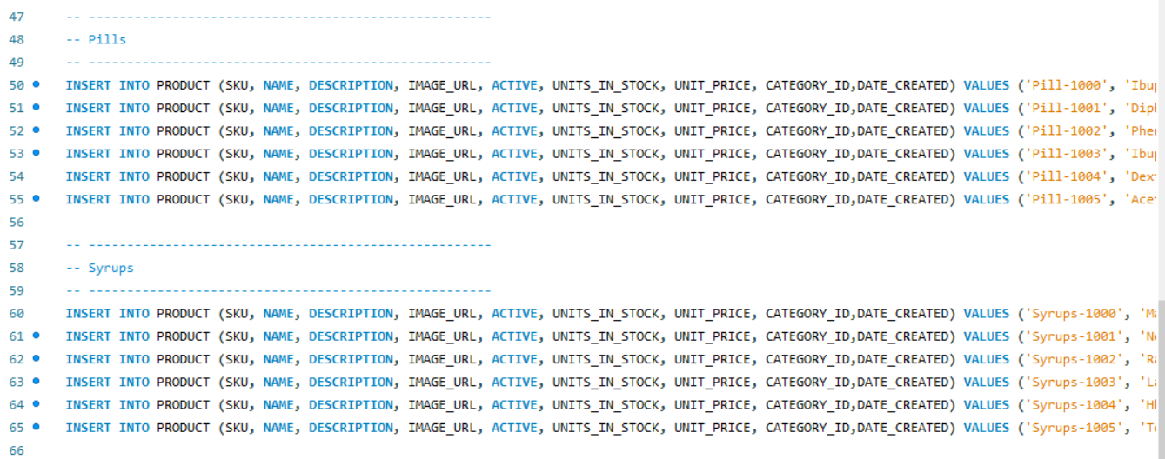

Data Result Set:

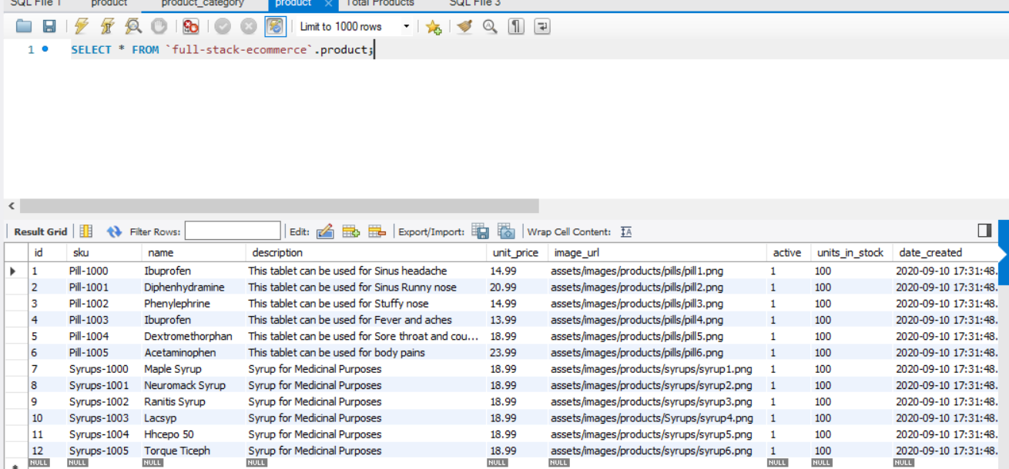

**BACKEND REST API DEVELOPMENT**

SPRING INITIALIZER:

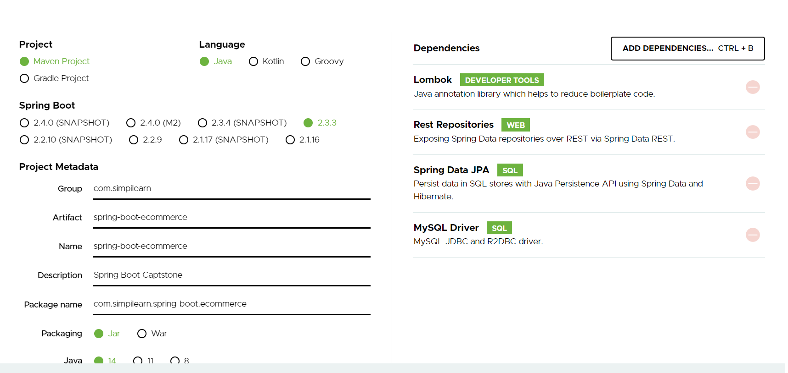

Project Structure:

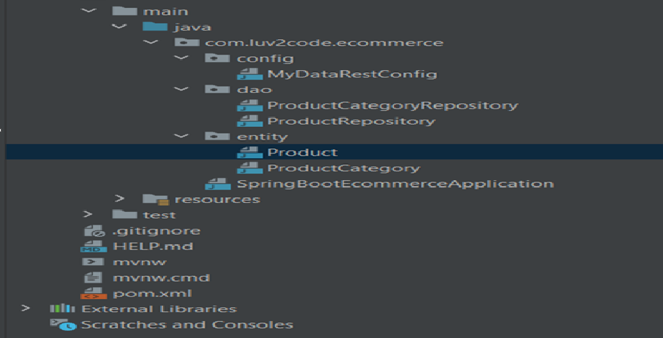

ProductEntity :

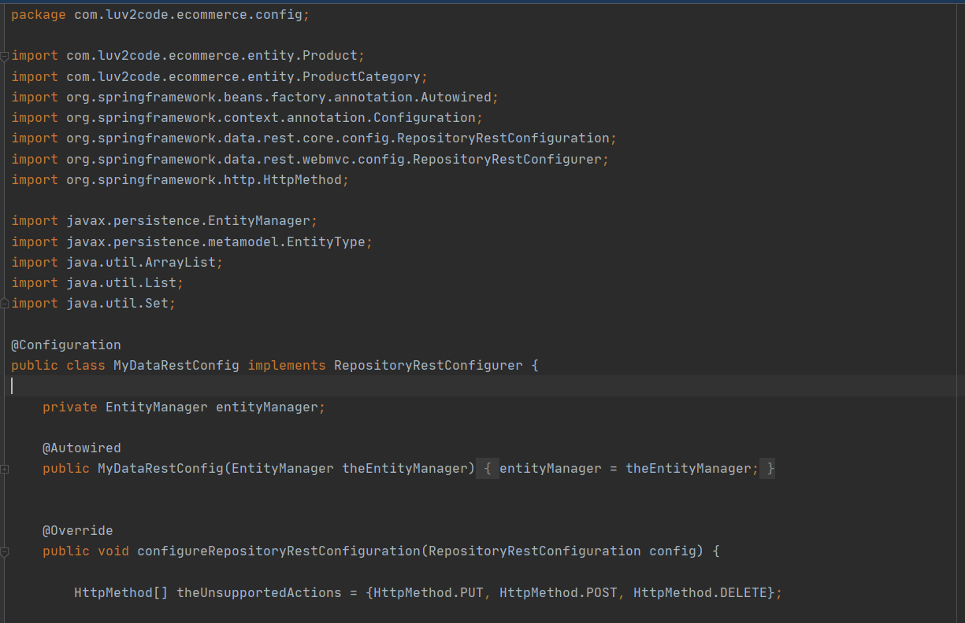

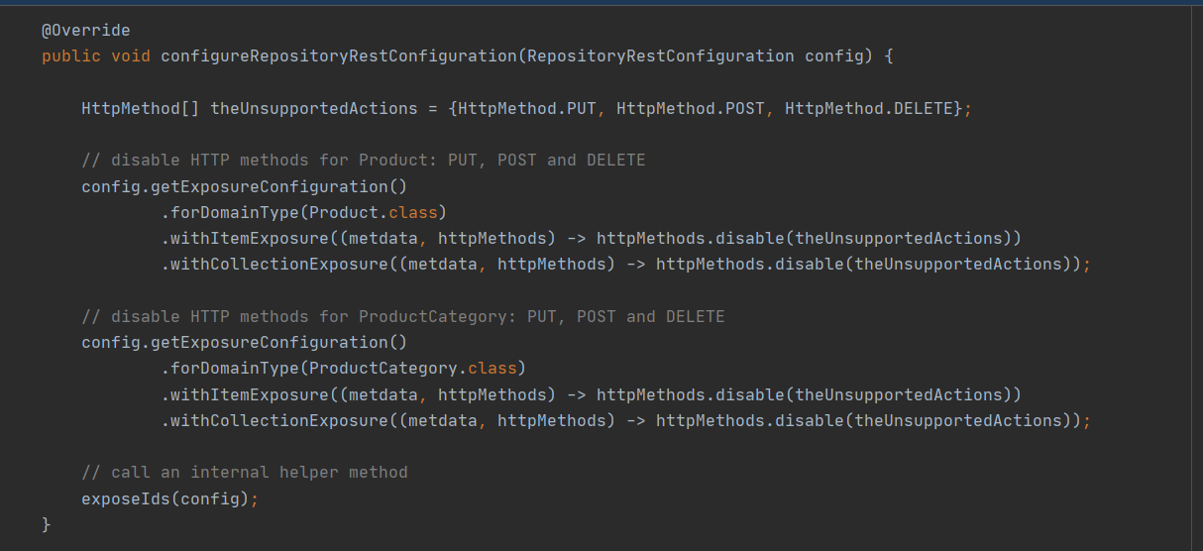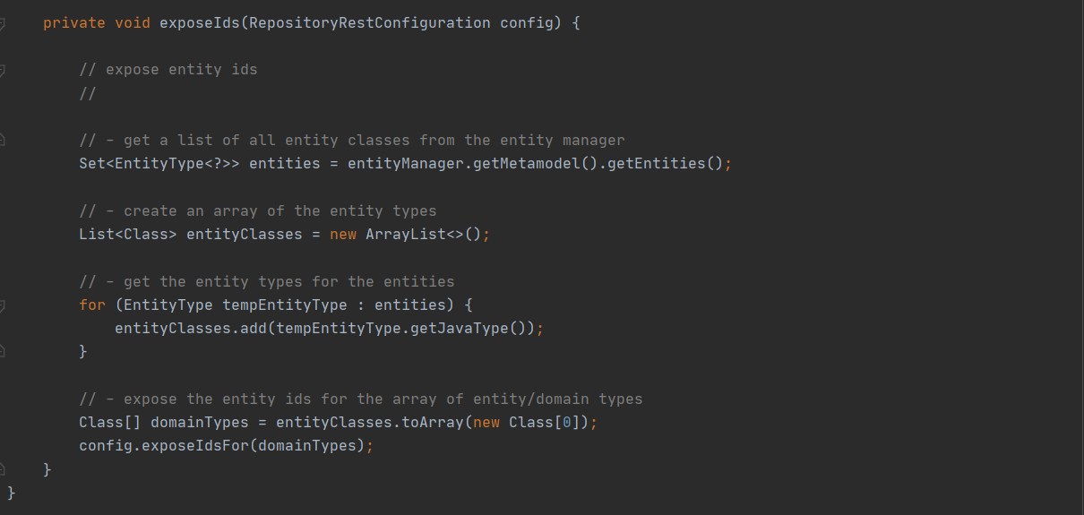

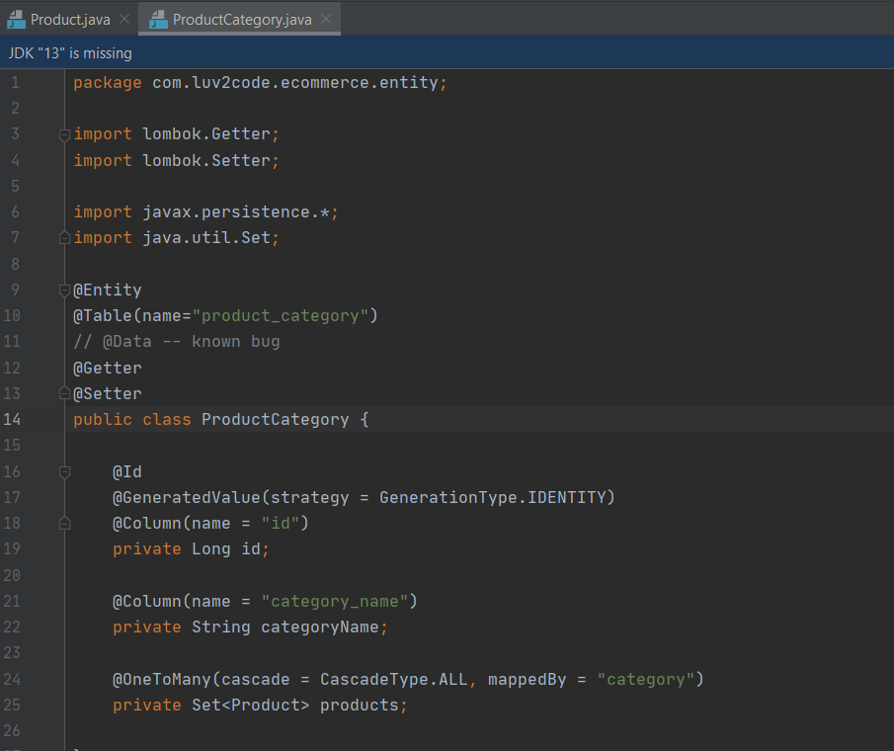Product Category Entity:

Product Repository:

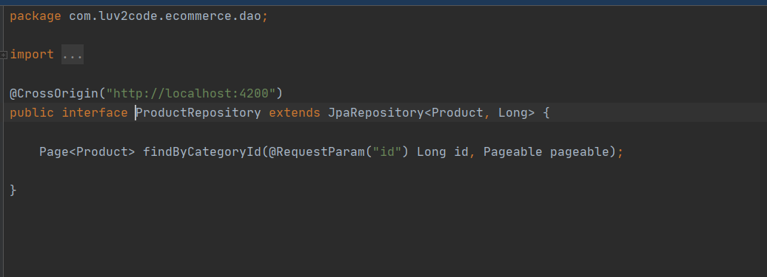

Product Category Repository:

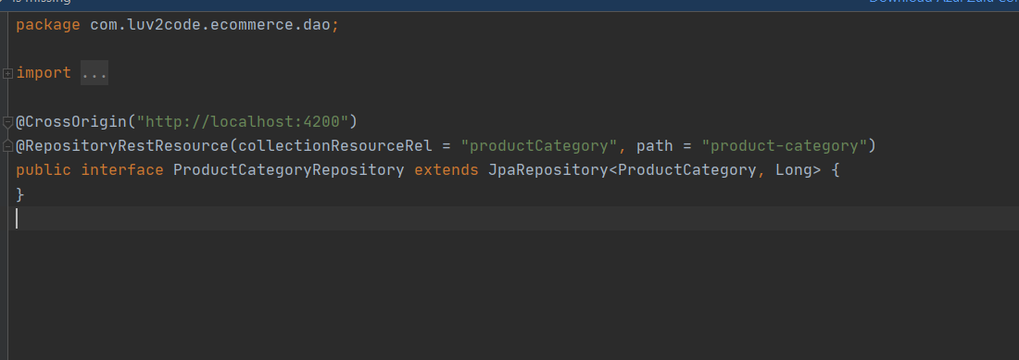

RestConfig:

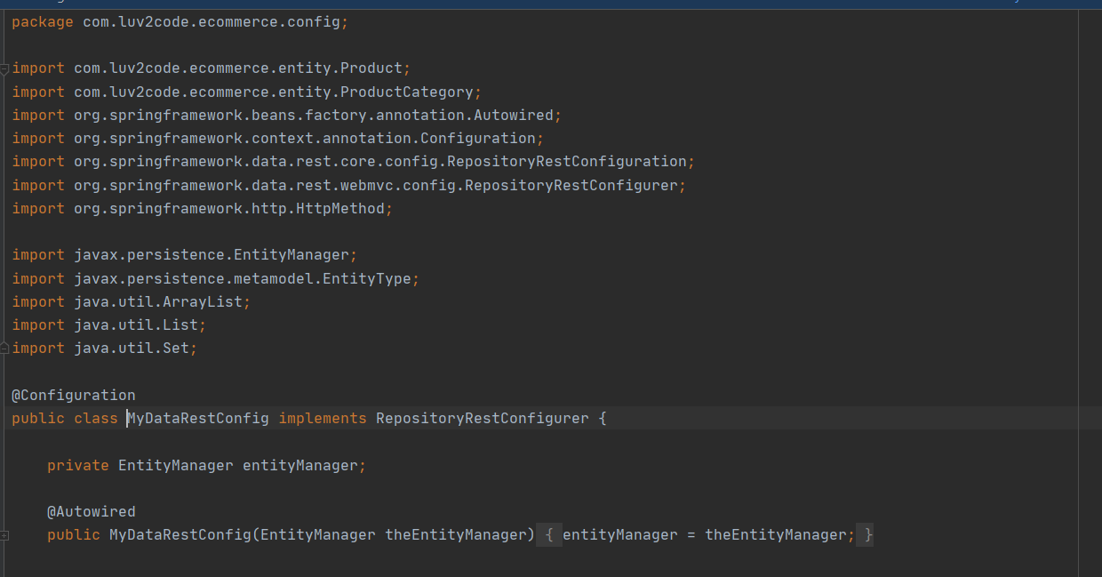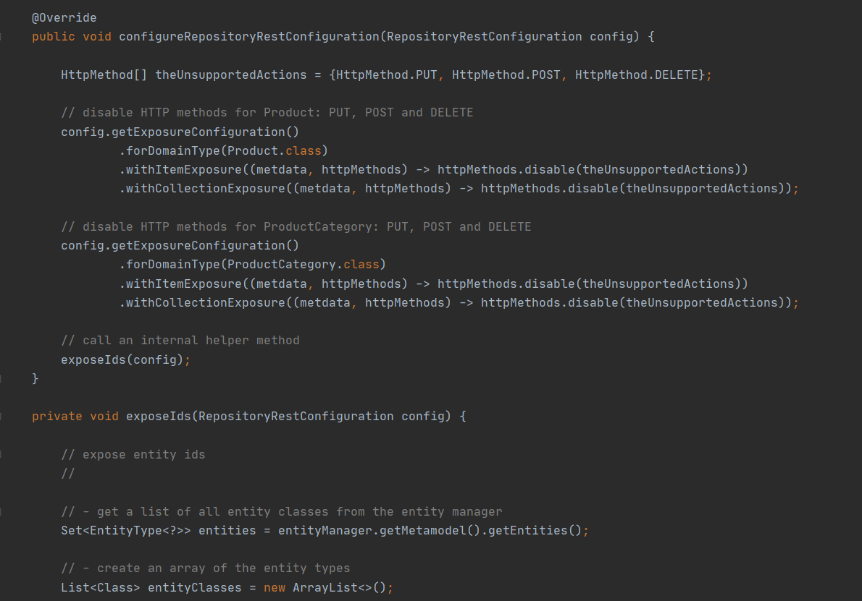

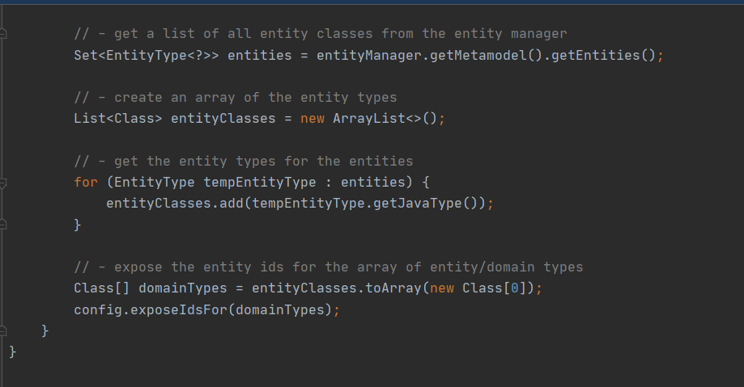

**FRONEND DEVELOPMENT**

FrontEnd Project Structure:

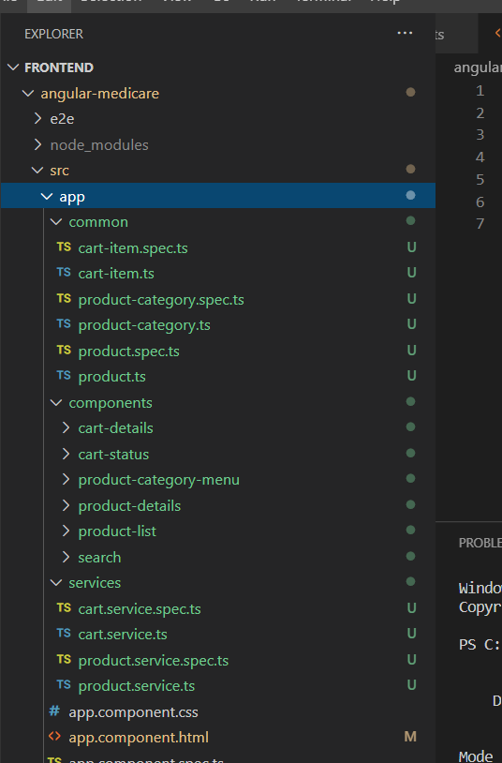

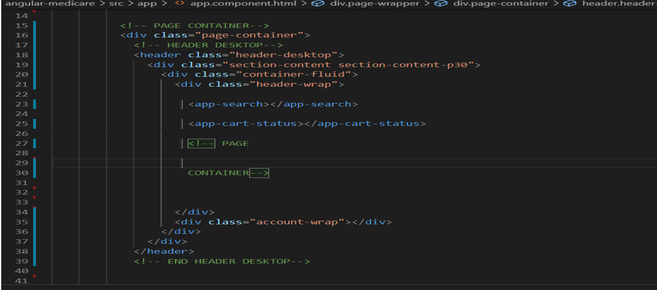

AppModule:

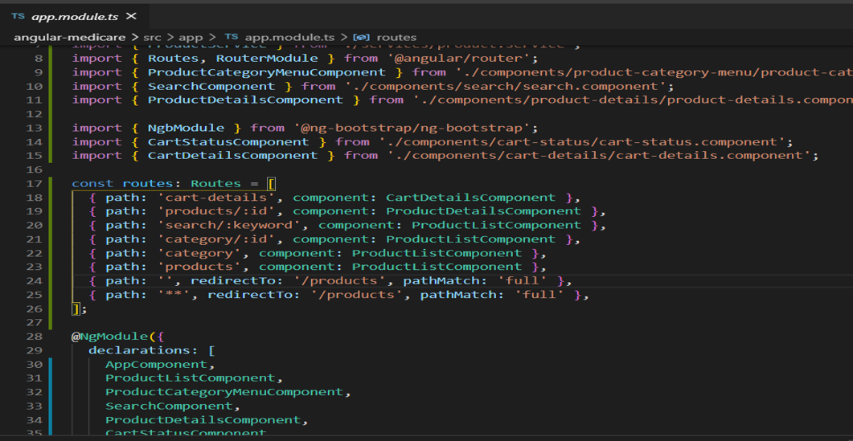

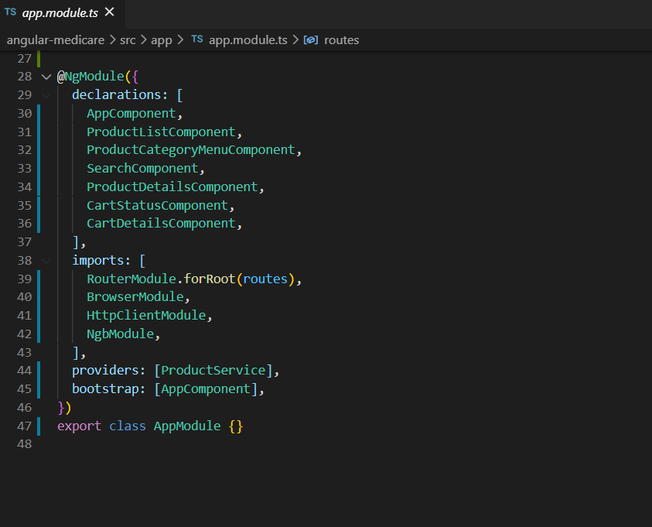

Product_List

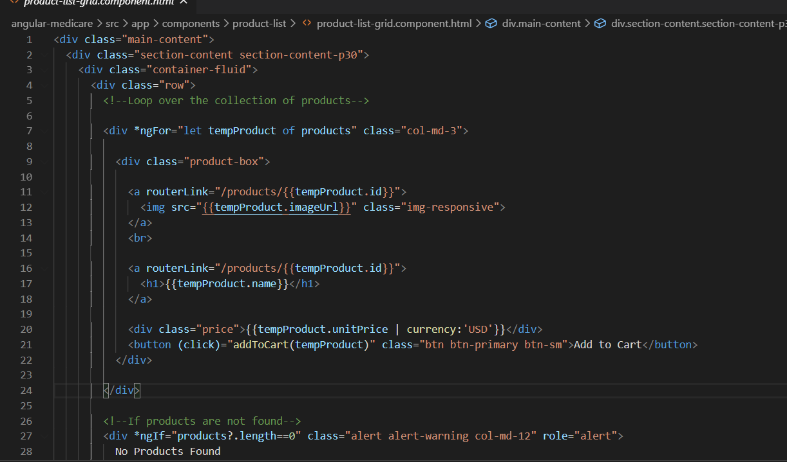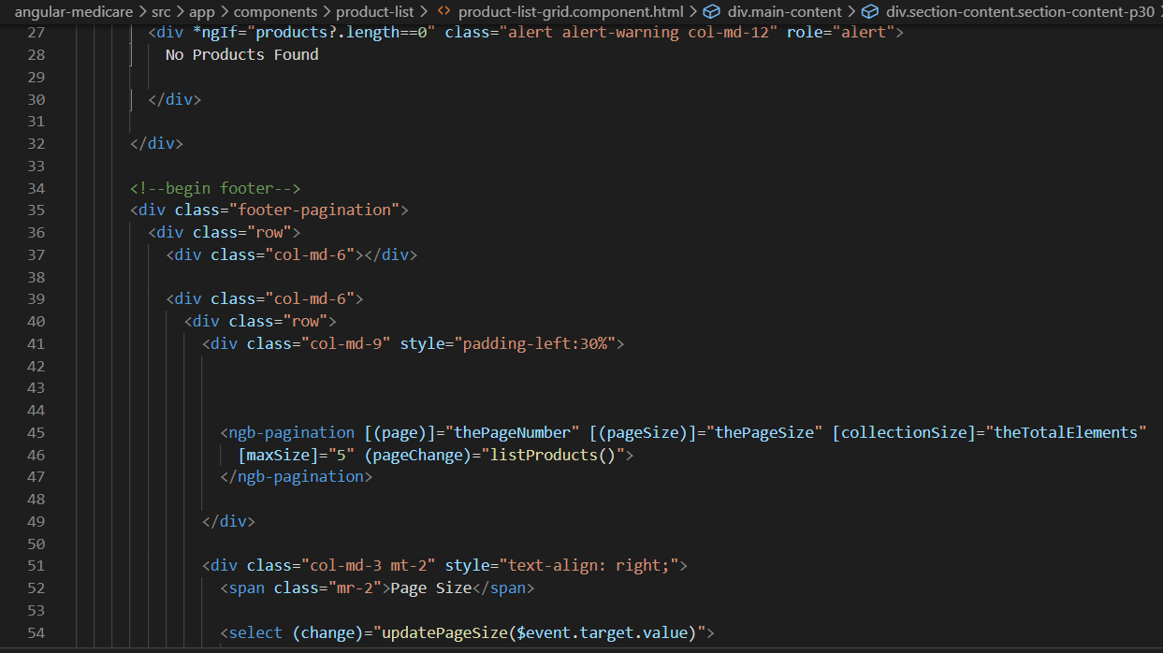

ProductList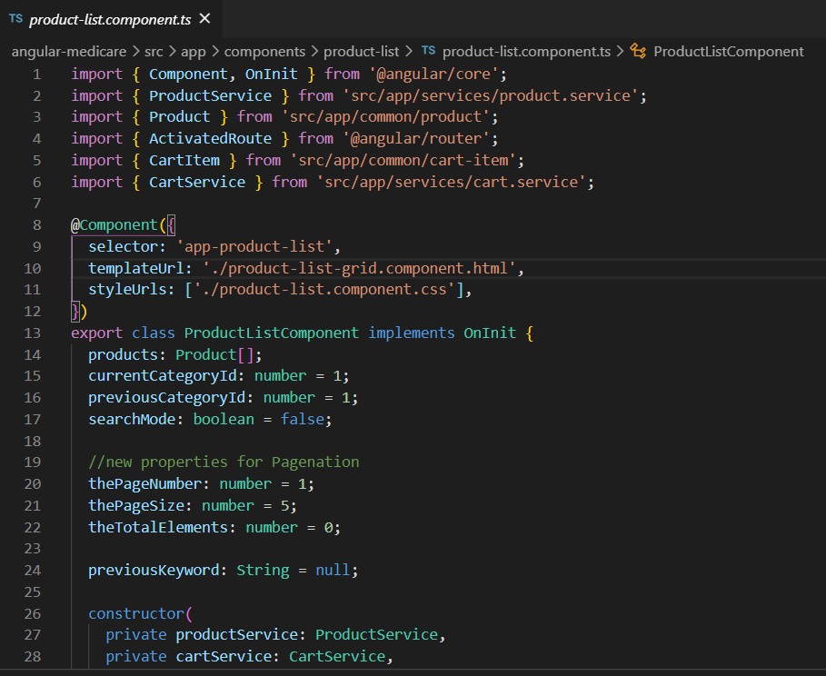

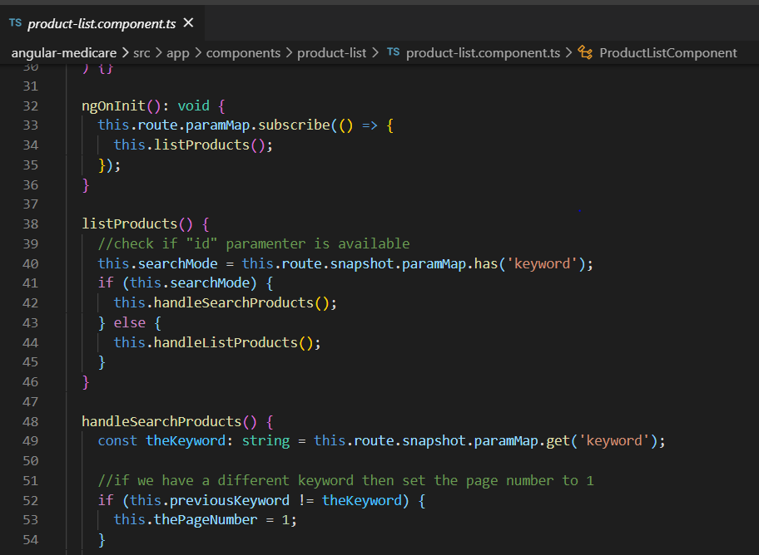

Product Details

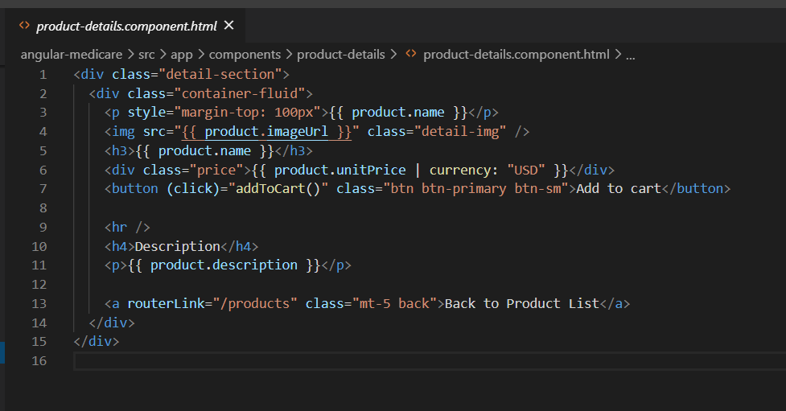

ProductDetails.ts

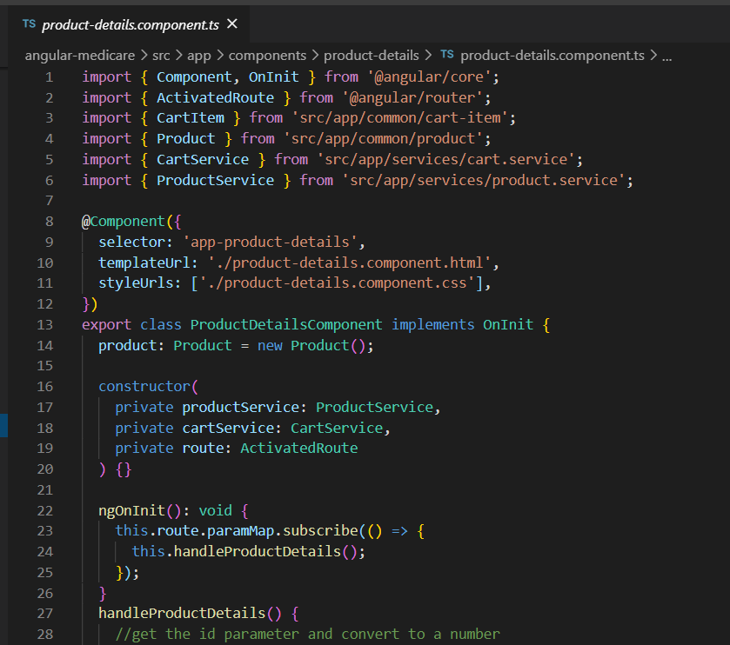

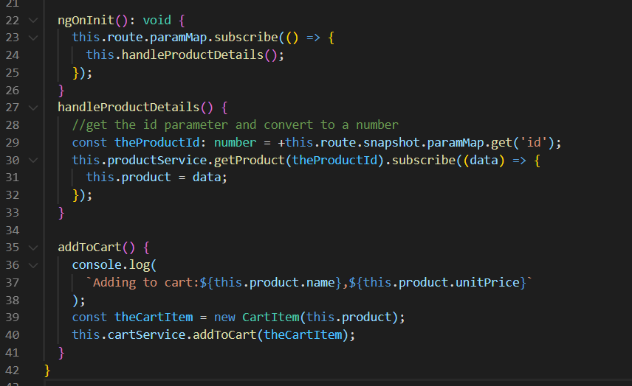

Product Category

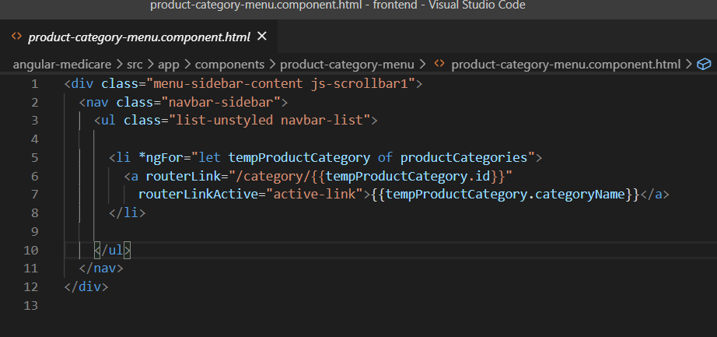

Product-category.ts

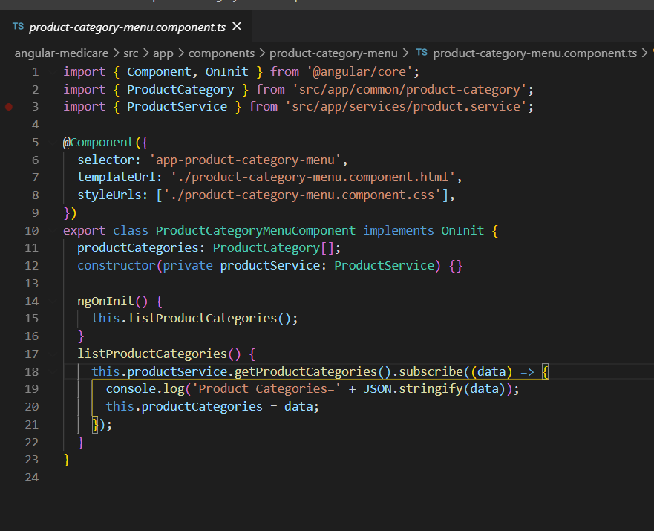

Backend output

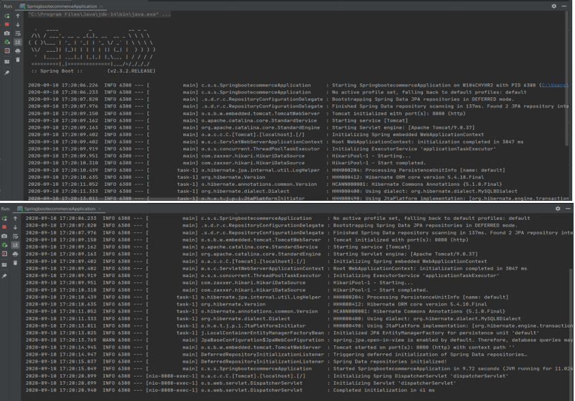

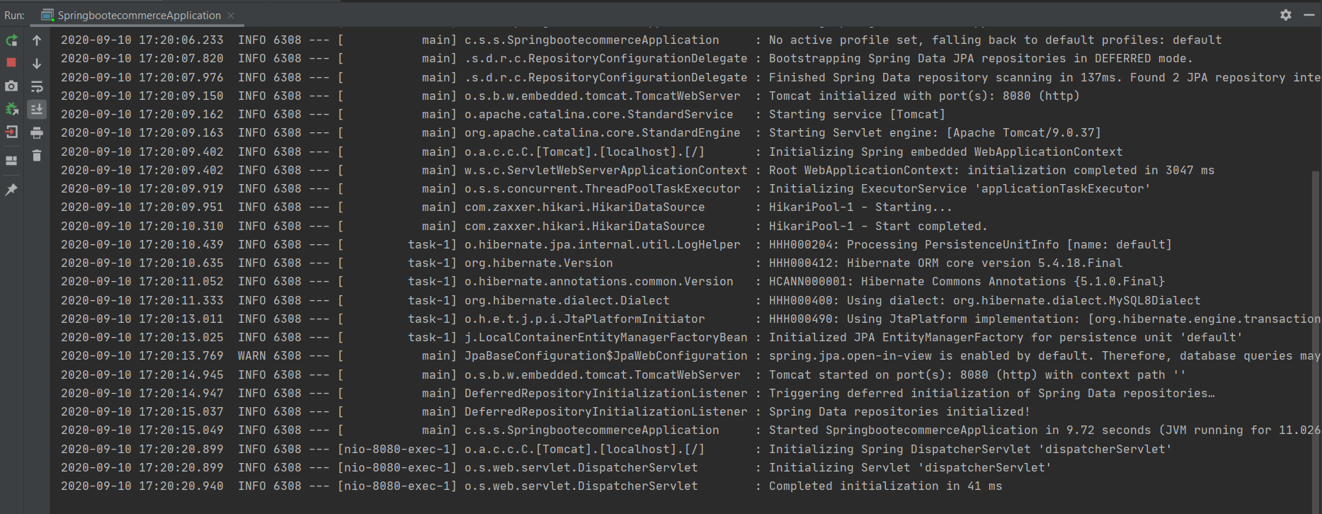

<http://localhost:8080/api>

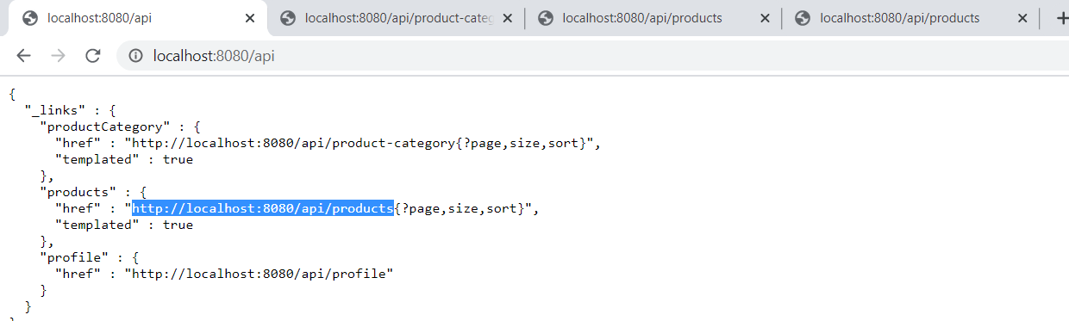

Json Url: [http://localhost:8080/api/product-category 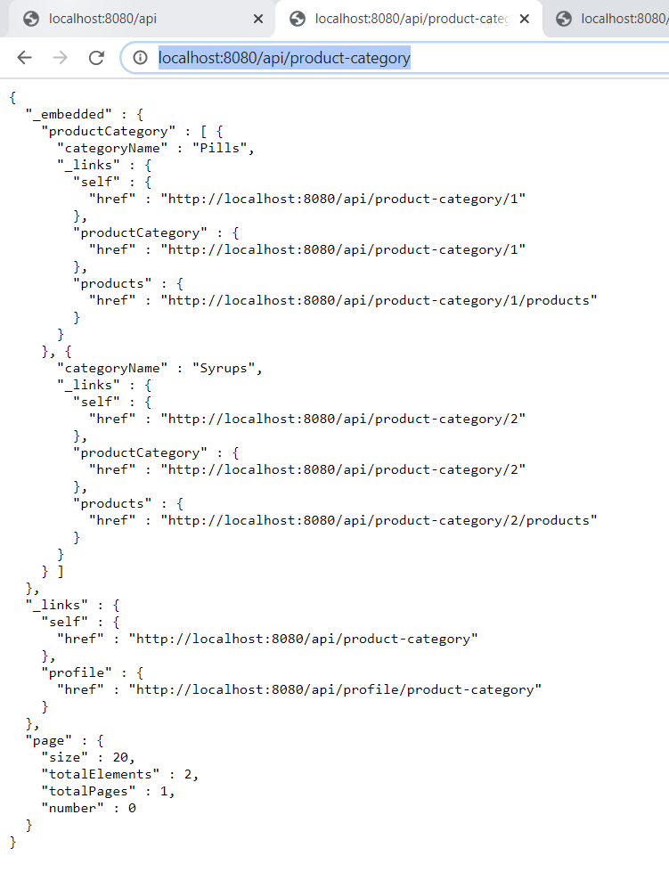](http://localhost:8080/api/product-category%20%20%20)

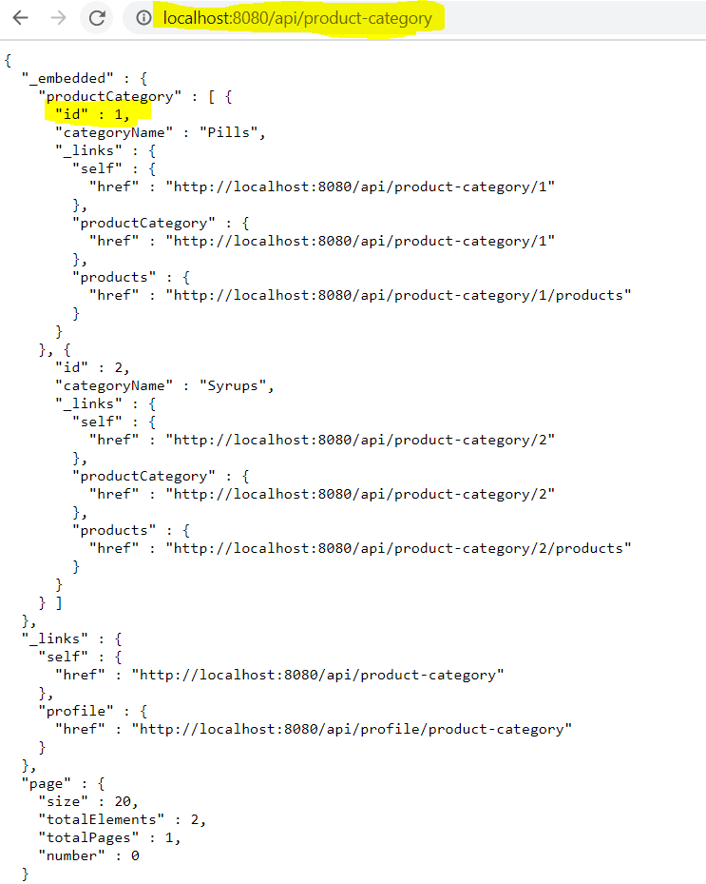

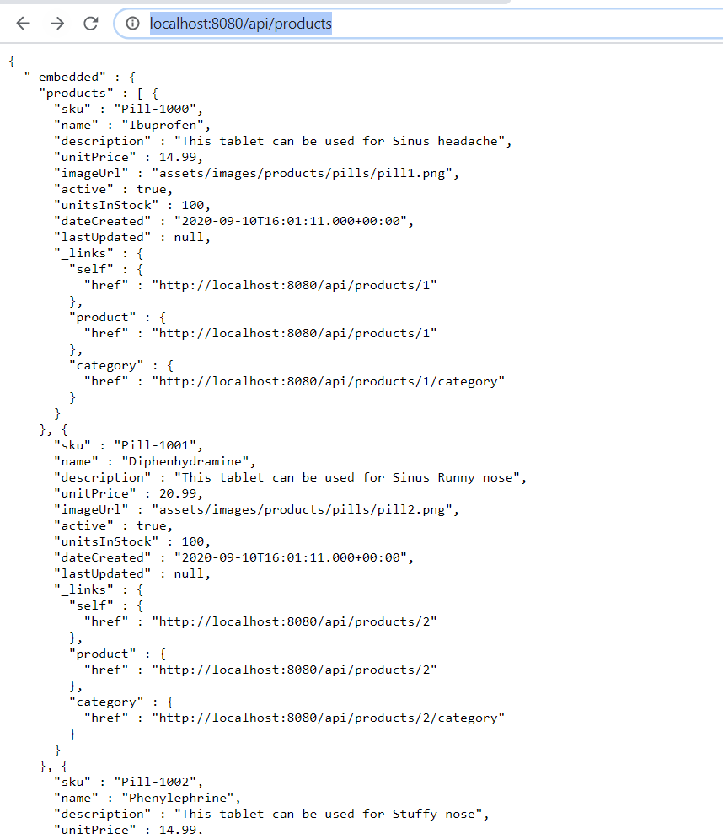<http://localhost:8080/api/products>

FRONTEND Angular Output

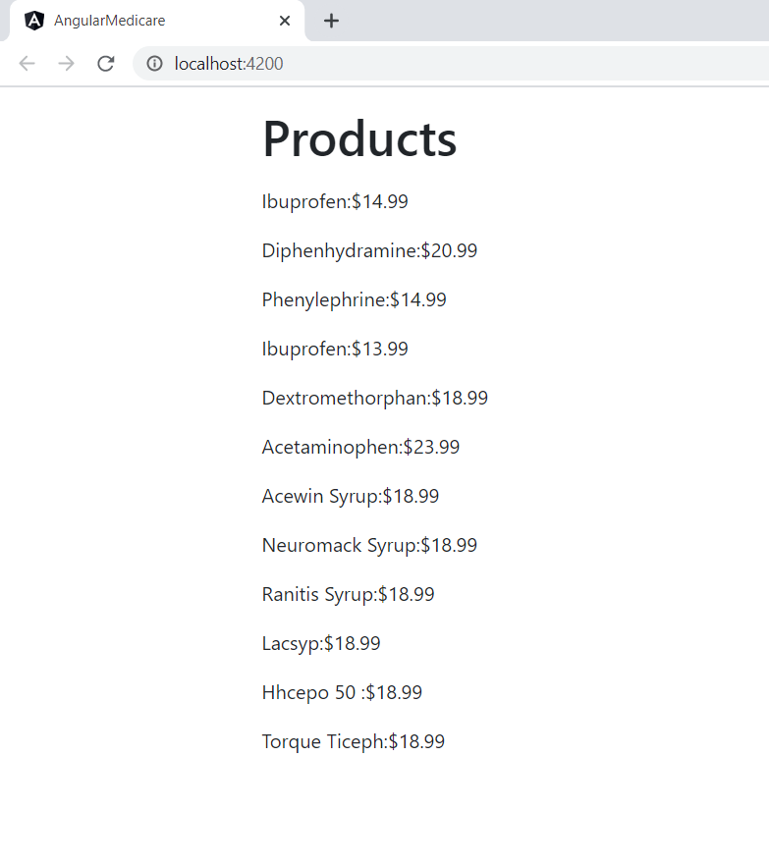

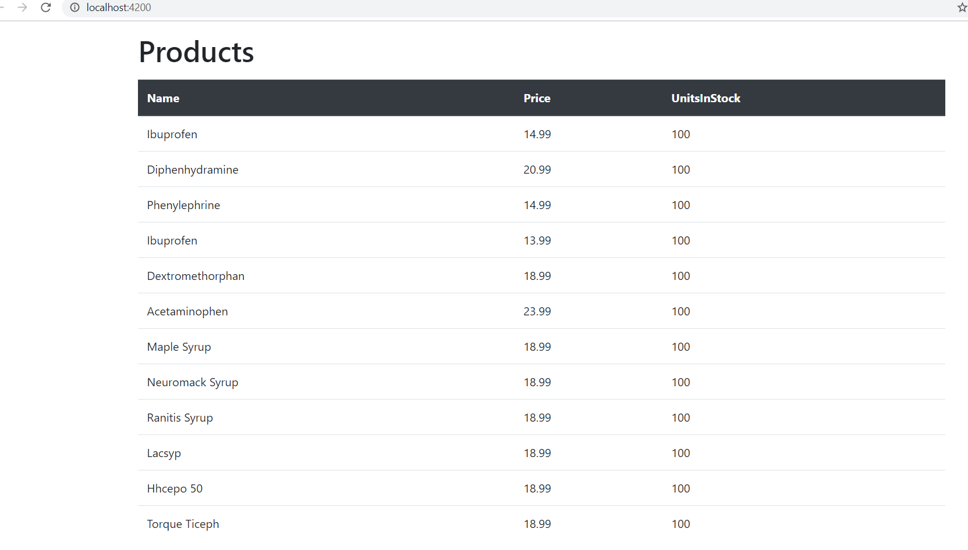

<http://localhost:8080/api/products/search/findByCategoryId?id=1>

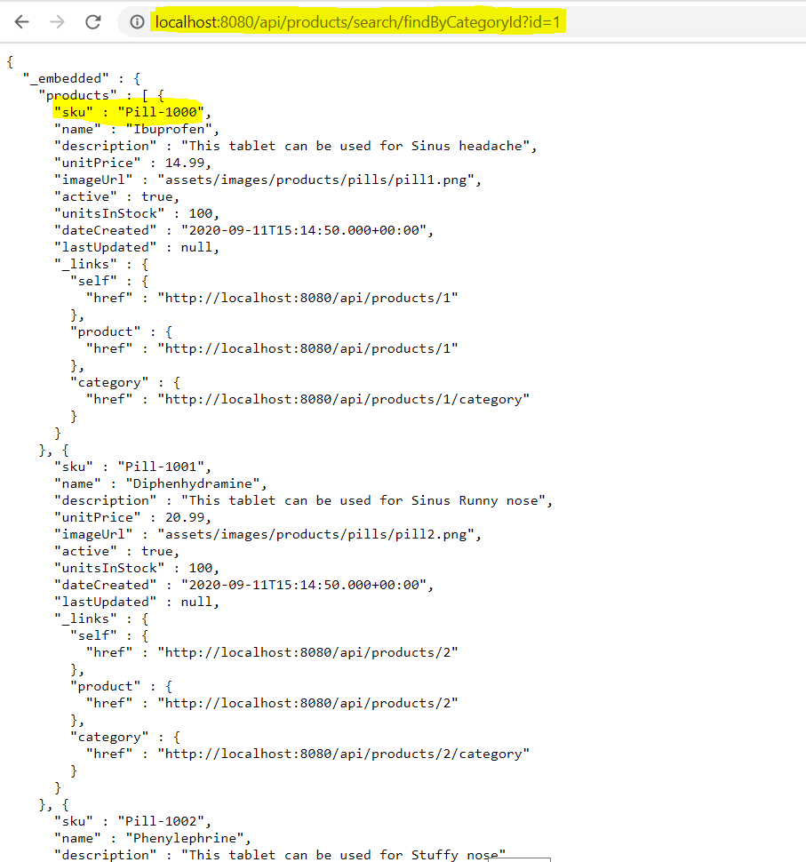

<http://localhost:8080/api/products/search/findByCategoryId?id=2>

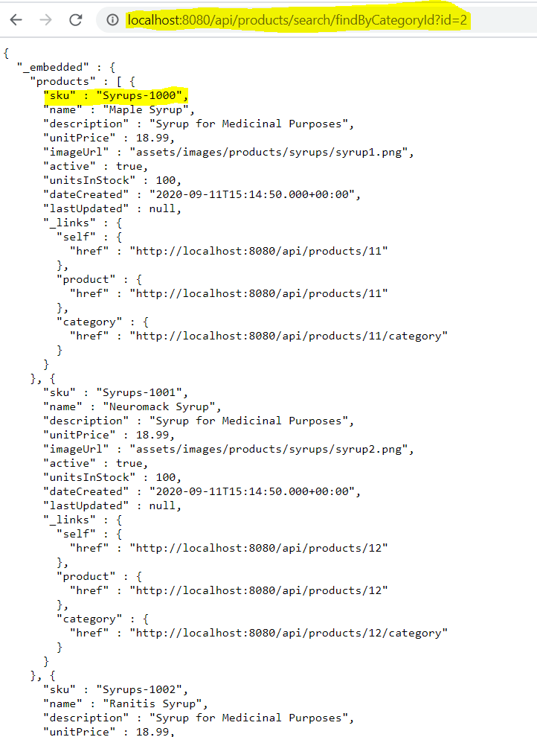

FindByNameContaining

<http://localhost:8080/api/products/search/findByNameContaining?name=Neuromack%20Syrup>

